Warframe — the free cooperative shooter from the third party with elements of a slesher developed by the Digital Extremes company for Playstation 4, Xbox One and Microsoft Windows. The main concept (characters, names, design of levels) are borrowed from the game Dark Sector. The player operates the member of race Tenno — the ancient soldier who woke up from century anabiosis for new wars, battles and resistance with hostile fractions — Grinir, race of the militarized people clones, the Case, merchant guild, and Infected. Tenno is used by suits which warframes are called and give them special abilities.

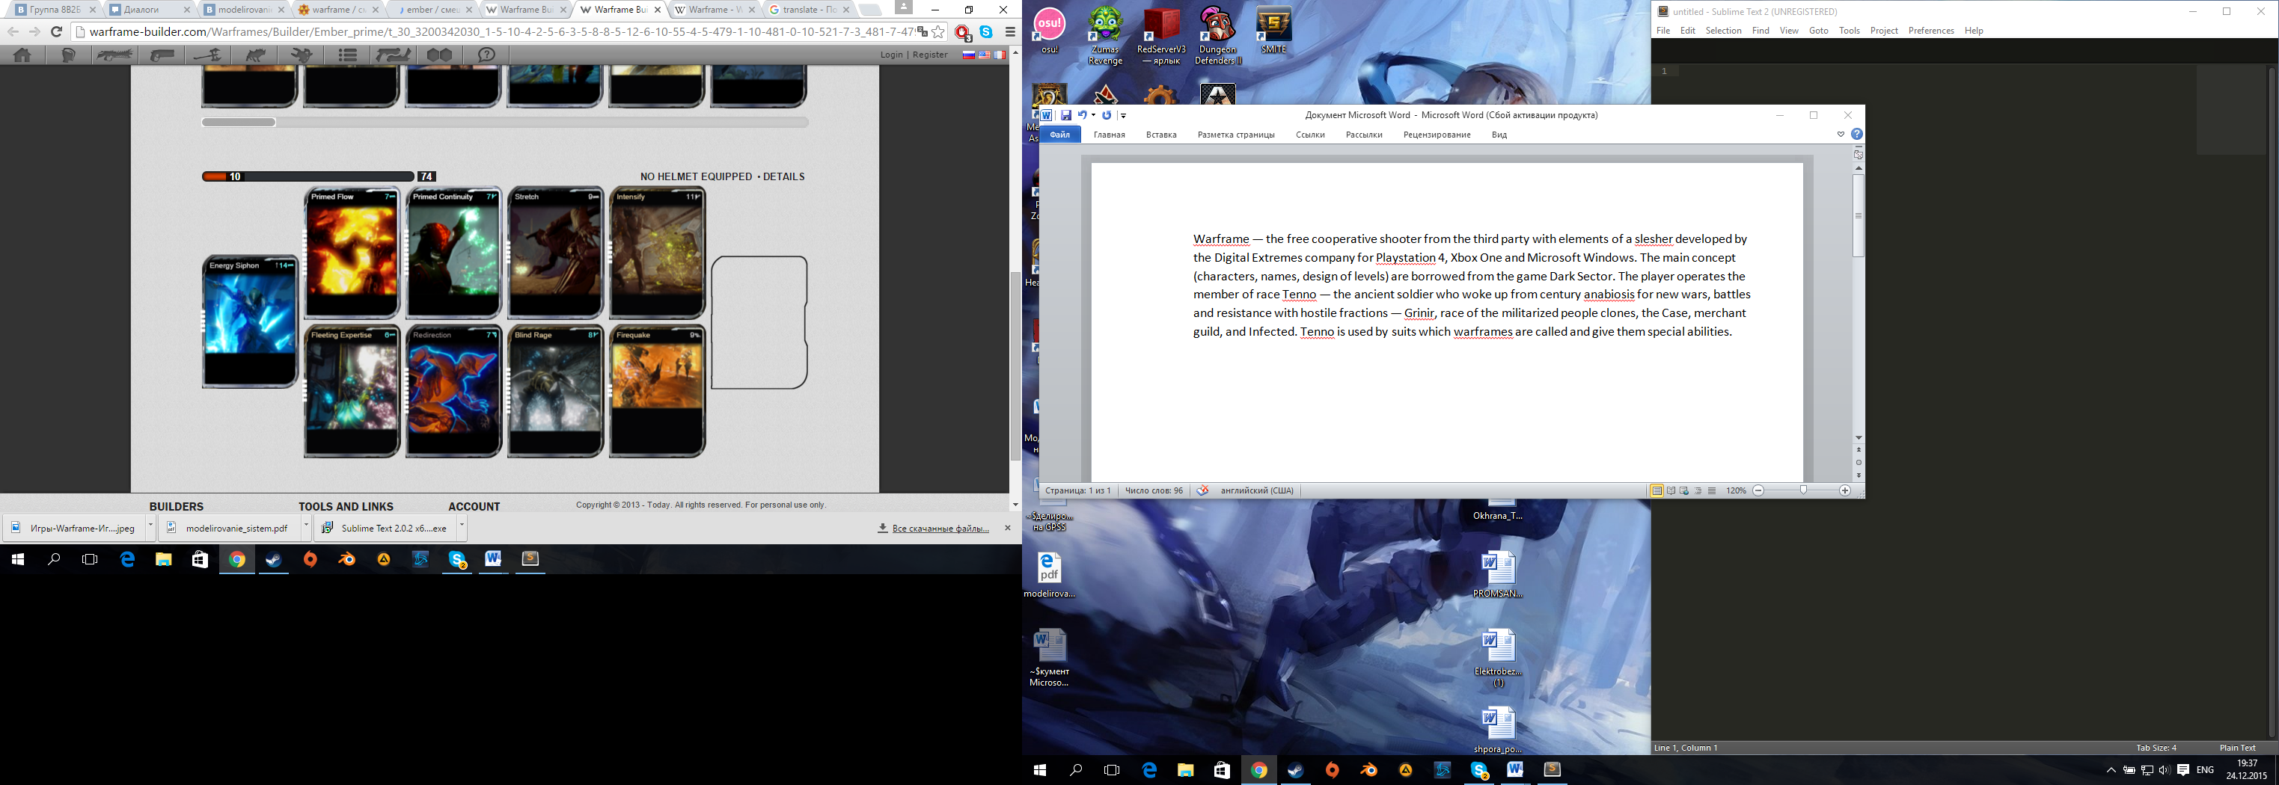

Aura: Energy Siphon lvl 5

Mods:

Primed Flow lvl 10

Primed Continuity lvl 10

Stretch lvl 5

Intensify lvl 5

Fleeting Expertise 5 lvl

Redirection lvl 10

Blind Rage lvl 10

Firequake lvl 3

Hello, today I will show you the site made by me.

On the main page, there is described what the Warframe actually is. Also there is represented a warframe unit on the site.

On the Main page I used these tags: div, table, Img, header1, header3 supplemented by other classes and id.

On the build page there is shown the most popular way to improve your character.

On the build page the same tags as in the main page are used, as well as of unordered lists and list elements.

On the abilities page the main abilities of warframe unit are shown.

Here is also I am using tags which were used in the previous pages.

On the page called History there is the small description of history connected with warrior Ember.

All of the main components of my site are located in the css file which is named a stylesheet.

And now on this slide there are described tag's proprerties' changes and also the properties of id and classes attributes.

Thank you for attention!